Ladders of Walking-Working Surfaces Training Material and Comprehension Quiz

- Policy
  - Ensure that each ladder used meets the requirements of this section.
  - The ladders used in emergency operations such as firefighting, rescue, and tactical law enforcement operations or training for these operations or designed into or is an integral part of the machines are not applicable to these requirements.
  - To recognize hazards and prevent accidents due to improper use of certain ladders.

- Procedure
  - The following are the general requirements for all ladders
    - Ladder rungs, steps, and cleats are parallel, level, and uniformly spaced when the ladder is in position for use.
    - Ladder rungs, steps, and cleats are spaced not less than 10 inches (25 cm) and not more than 14 inches (36 cm) apart, as measured between the centerlines of the rungs, cleats, and steps, except that:
      - Ladder rungs and steps in elevator shafts are spaced not less than 6 inches (15 cm) apart and not more than 16.5 inches (42 cm) apart, as measured along the ladder side rails; and
      - Fixed ladder rungs and steps on telecommunication towers are spaced not more than 18 inches (46 cm) apart, measured between the centerlines of the rungs or steps.
    - Steps on stepstools are spaced not less than 8 inches (20 cm) apart and not more than 12 inches (30 cm) apart, as measured between the centerlines of the steps.
    - Ladder rungs, steps, and cleats have a minimum clear width of 11.5 inches (29 cm) on portable ladders and 16 inches (41 cm) (measured before installation of ladder safety systems) for fixed ladders, except that:
      - The minimum clear width does not apply to ladders with narrow rungs not designed to be stepped on, such as those located on the tapered end of orchard ladders and similar ladders.
      - Rungs and steps of manhole entry ladders supported by the manhole opening must have a minimum clear width of 9 inches (23 cm).
      - Rungs and steps on rolling ladders used in telecommunication centers must have a minimum clear width of 8 inches (20 cm); and
      - Stepstools have a minimum clear width of 10.5 inches (26.7 cm).
    - Wooden ladders are not coated with any material that may obscure structural defects.
    - Metal ladders are made with corrosion-resistant material or protected against corrosion.
    - Ladder surfaces are free of puncture and laceration hazards.
    - Ladders are used only for the purposes they were designed.
    - Ladders are inspected before initial use in each work shift and more frequently as necessary to identify any visible defects that could cause employee injury.
    - Any ladder with structural or other defects is immediately tagged "Dangerous: Do Not Use" or with similar language by § 1910.145 and removed from service until repaired by § 1910.22(d) or replaced.
    - Each employee faces the ladder when climbing up or down it
    - Each employee uses at least one hand to grasp the ladder when climbing up and down it; and
    - No employee carries any object or load that could cause the employee to lose balance and fall while climbing up or down the ladder.
  - Portable Ladders
    - Rungs and steps of portable metal ladders are corrugated, knurled, dimpled, coated with skid-resistant material, or otherwise treated to minimize the possibility of slipping.
    - Each stepladder or combination ladder used in a stepladder model is equipped with a metal spreader or locking device that securely holds the front and back sections in an open position while the ladder is in use.
    - Ladders are not loaded beyond the maximum intended load. (Refer to 1910.21 (b))
    - Ladders are used only on stable and level surfaces unless secured or stabilized to prevent accidental displacement.
    - No portable single-rail ladders are used.
    - No ladder is moved, shifted, or extended while an employee is on it.
    - Ladders placed in locations such as passageways, doorways, or driveways where they can be displaced by other activities or traffic:
      - Are secured to prevent accidental displacement; or
      - Are guarded by a temporary barricade, such as a row of traffic cones or caution tape, to keep the activities or traffic away from the ladder.
    - The cap (if equipped) and the top step of a stepladder are not used as steps.
    - Portable ladders used on slippery surfaces are secured and stabilized.
    - The top of a non-self-supporting ladder is placed so that both side rails are supported unless the ladder is equipped with a single support attachment.
    - Portable ladders used to gain access to an upper landing surface have side rails that extend at least 3 feet (0.9 m) above the upper landing surface (see Figure D-1 of this section);

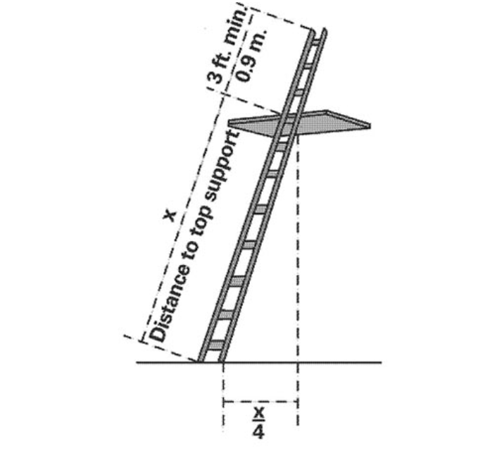

Figure D-1 – Portable Ladder Set-Up

    - Ladders and ladder sections are not tied or fastened together to provide added length unless they are specifically designed for such use.
    - Ladders are not placed on boxes, barrels, or other unstable bases for additional height.
  - Fixed Ladders
    - Fixed ladders are capable of supporting their maximum intended load.
    - The minimum perpendicular distance from the centerline of the steps or rungs, or grab bars, or both, to the nearest permanent object in the back of the ladder, is 7 inches (18 cm), except for elevator pit ladders, which have a minimum perpendicular distance of 4.5 inches (11 cm).
    - Grab bars do not protrude on the climbing side beyond the ladder rungs they serve.
    - The side rails of through or side-step ladders extend at least 42 inches (1.1 m) above the top of the ladder's access level or landing platform. For parapet ladders, the access level is:
      - The roof of the parapet is cut to permit passage through the parapet; or
      - The top of the parapet if the parapet is continuous.
    - The steps or rungs are omitted from the extensions for through ladders, and the side rails are flared to provide not less than 24 inches (61cm) and not more than 30 inches (76 cm) of clearance.
    - When a ladder safety system is provided, the maximum clearance between the side rails of the extension must not exceed 36 inches (91 cm).
    - For side-step ladders, the side rails, rungs, and steps must be continuous in the extension (see Figure D-2 of this section).
    - Grab bars extend 42 inches (1.1 m) above the access level or landing platforms served by the ladder.
    - The grab bars' minimum size (cross-section) is the same as the ladder's rungs.
    - When a fixed ladder terminates at a hatch (see Figure D-3 of this section), the hatch cover:
      - Opens with sufficient clearance to provide easy access to or from the ladder; and
      - Opens at least 70 degrees from horizontal if the hatch is counterbalanced.
    - Individual-rung ladders are constructed to prevent the employee's feet from sliding off the ends of the rungs (see Figure D-4 of this section).
    - Fixed ladders having a pitch greater than 90 degrees from the horizontal are not used.
    - The step-across distance from the centerline of the rungs or steps is:
      - For through ladders, not less than 7 inches (18 cm) and not more than 12 inches (30 cm) to the nearest edge of the structure, building, or equipment accessed from the ladders.
      - For side-step ladders, not less than 15 inches (38 cm) and not more than 20 inches (51 cm) to the access points of the platform edge.
    - Fixed ladders that do not have cages or wells have:
      - A clear width of at least 15 inches (38 cm) on each side of the ladder centerline to the nearest permanent object; and
      - A minimum perpendicular distance of 30 inches (76 cm) from the centerline of the steps or rungs to the nearest object on the climbing side. When unavoidable obstructions are encountered, the minimum clearance at the obstruction may be reduced to 24 inches (61 cm), provided deflector plates are installed (see Figure D-5 of this section).
    - Refer to Duty to have fall protection and falling object protection Program and Fall Protection Systems and Falling Object Protection-Criteria and Practices Program.

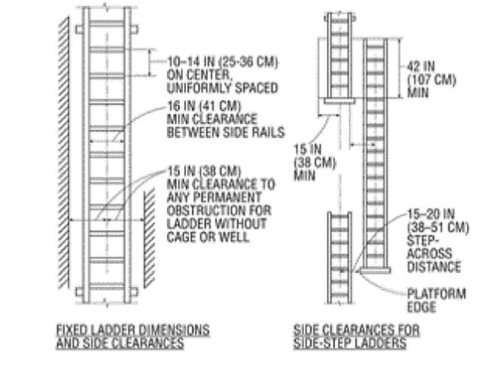

Figure D-2 – Side-Step Fixed Ladder Sections
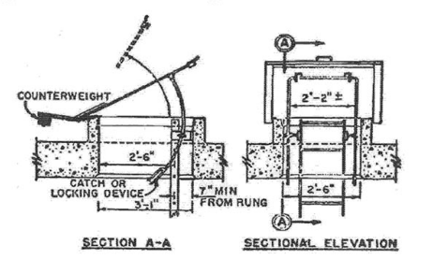

Figure D-3 – Example of Counterbalanced Hatch Cover a Roof

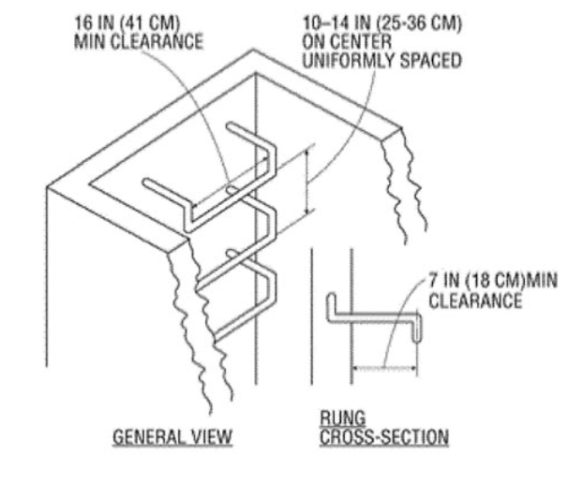
Figure D-4 – Example of Counterbalanced Hatch Cover a Roof

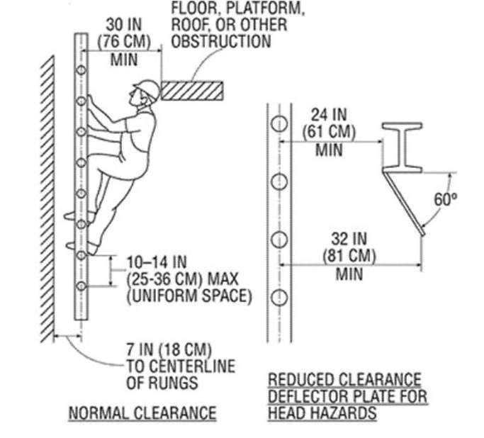

Figure D-5 – Individual Rung Ladder

  - Mobile ladder stands and mobile ladder stand platforms
    - The general requirements are the following:
      - Mobile ladder stands and platforms have a step width of at least 16 inches (41 cm).
      - The steps and platforms of the mobile ladder stand and platforms are slip-resistant.
      - Slip-resistant surfaces must be either an integral part of the design and construction of the mobile ladder stand and platform or provided as a secondary process or operation, such as dimpling, knurling, shot blasting, coating, spraying, or applying durable slip-resistant tapes.
      - Mobile ladder stands and platforms can support at least four times their maximum intended load.
      - Wheels or casters under load can support their proportional share of four times the maximum intended load, plus their proportional share of the unit's weight.
      - Unless otherwise specified in this section, mobile ladder stands and platforms with a top step height of 4 feet (1.2 m) or above have handrails with a vertical height of 29.5 inches (75 cm) to 37 inches (94 cm), measured from the front edge of a step.
      - Removable gates or non-rigid members, such as chains, may be used instead of handrails in special applications.
      - The maximum work-surface height of mobile ladder stands and platforms does not exceed four times the shortest base dimension without additional support.
      - Outriggers, counterweights, or comparable means that stabilize the mobile ladder stands and platforms and prevent overturning are used for greater height for greater heights.
      - Mobile ladder stands and platforms that have wheels or casters are equipped with a system to impede horizontal movement when an employee is on the stand or platform; and
      - No mobile ladder stands or platform moves when an employee is on it.
      - Design requirements for mobile ladder stands to ensure the following:
        - Steps are uniformly spaced and arranged, with a rise of not more than 10 inches (25 cm) and a depth of not less than 7 inches (18 cm).
        - The slope of the step stringer to which the steps are attached must not be more than 60 degrees, measured from the horizontal.
        - Mobile ladder stands with a top step height above 10 feet (3 m) have the top step protected on three sides by a handrail with a vertical height of at least 36 inches (91 cm); and top steps that are 20 inches (51 cm) or more, front to back, have a mid-rail and toe board. Removable gates or non-rigid members, such as chains, may be used instead of handrails in special-use applications; and
        - The standing area of the mobile ladder stands is within the base frame.
    - Design requirements for mobile ladder stand platforms.
      - The steps of mobile ladder stand platforms meet the requirements of this section. Demonstrates that the requirement is not feasible. Steeper slopes or vertical rung ladders may be used, provided the units are stabilized to prevent overturning.
      - Mobile ladder stand platforms with a platform height of 4 to 10 feet (1.2 m to 3 m) have, in the platform area, handrails with a vertical height of at least 36 inches (91 cm) and mid-rails; and
      - All ladder stand platforms with a platform height above 10 feet (3 m) have guardrails and toe boards on the exposed sides and ends of the platform.
      - Removable gates or non-rigid members, such as chains, may be used on mobile ladder stand platforms instead of handrails and guardrails in special-use applications.

- Responsibility
  - Management
    - Ensures ladder Inspections are a vital part of using ladders' safety. They are checked before every use and regularly by a competent person every 3 to 6 months.
    - Comply with all pertinent OSHA/safety rules and regulations.
  - Human Resources/Department Managers/Supervisors
    - Conduct Training for all Employees on proper usage, maintenance, and safety measures of ladders.
  - All Employees/ Process Owners
    - Have training in the proper use of ladders intended for use.
    - Attend training periodically.

- Corrective Action
  - The most important thing to remember is that ladder accidents are preventable with proper training and education.
    - Incorrect extension ladder angle – The optimal angle for an extension ladder is 75 degrees. Extreme angles make the ladder more likely to slide from underneath the user, leading to dangerous falls.
    - Inappropriate ladder selection - Pick the right ladder for the job
    - Insufficient ladder inspection - Use a well-maintained ladder
    - Improper ladder use. Following OSHA's guidelines on ladder safety recommend maintaining three points of contact with the ladder whenever climbing or descending.
  - If any item needs repair, tag the ladder 'Do Not Use' and remove it from service.

- Review - Quality
  - Review the general requirements for the development of rules and regulations.
  - Confirm that the general requirements comply with the standards.
  - Review the documentation of the process with the relevant departments.
  - A review of these general requirements is conducted periodically.

- History
Revision No.: | Revision Date: | Description of Change: | Originator / Author Name: | Title / Department:
0 | 20220901 | Original | Arnel Ryan | PCQI / Compliance
1 | 20231130 | - Aligned with the updated program.  - Updated Policy, Procedure and Responsibility.  - Added Comprehension Quiz: ANSWER KEY | Arnel Ryan | PCQI / Compliance
2 | 20241002 | - Changed Lesson to Training Material and Comprehension Quiz in Title  - Change email from services@consultareinc.com to rfp@consultareinc.com | Arnel Ryan | PCQI / Compliance

Requirements:
- The trainee has read or received a verbal translation of all or part of the policy, procedure, method, and/or SOP for which they are being trained.
- The trainee has demonstrated the task they are to perform or the procedure for which they are being trained as required.
- The trainee has demonstrated the ability to perform the task with acceptable proficiency and minimal supervision.

TRAINEE (Print Name): | TRAINEE (Signature): | Date: | Department:
Trainer / Supervisor (Print Name): | Trainer (Signature): | Date: | Department:

UPON COMPLETION – EMAIL TO rfp@consultareinc.com

NAME (Print): | Date:

Ladders of Walking-Working Surfaces Comprehension Quiz

Direction: Choose the best answer and encircle the letter.

- Steps on stepstools are spaced not less than ___________ apart and not more than __________ apart, as measured between the centerlines of the steps.
  - 8 Inches (20 cm), 12 Inches (30 cm)
  - 8 Inches (30 cm), 12 Inches (40 cm)
  - 9 Inches (22 cm), 12 Inches (30 cm)

- Who is responsible for complying with all pertinent OSHA/safety rules and regulations?
  - Management
  - Supervisor
  - Employee

- Portable ladders used to gain access to an upper landing surface have side rails that extend at least _________ above the upper landing surface.
  - 7 Feet
  - 3 Feet
  - 8 Feet

- Ladders are not loaded beyond the maximum intended load.
  - True
  - False

- The side rails of through or side-step ladders extend at least __________above the top of the ladder's access level or landing platform.
  - 42 Inches
  - 32 Inches
  - 40 Inches

UPON COMPLETION – EMAIL TO rfp@consultareinc.com

